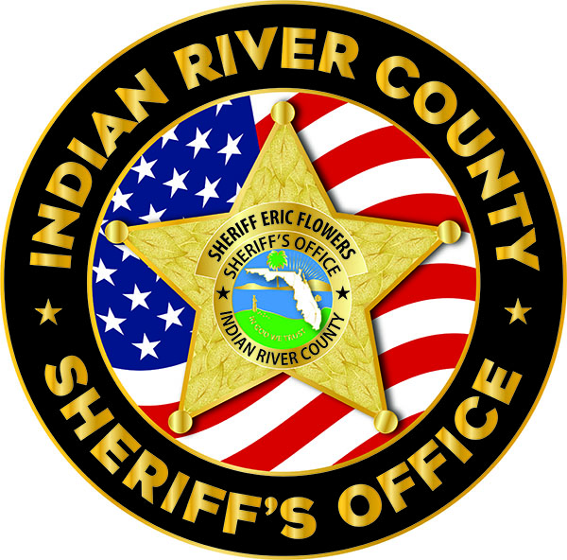

INDIAN RIVER COUNTY SHERIFF’S OFFICE
WAIVER OF LIABILITY AND HOLD HARMLESS AGREEMENT (ADULTS)

Name: _______________________________________________

Event/Program: ________________________________________

I agree to release, waive, discharge and covenant not to sue the Indian River County Sheriff’s Office, along with its officers, directors, supervisors, agents, servants or employees (collectively referred to here as ‘releasee’) from any and all liabilities, claims, demands, or causes of action that may arise from or be related to any loss, damage, or injury, including death, that may be sustained by me and my property while I am participating in the event or activity. I UNDERSTAND THAT THIS MEANS THAT I AGREE NOT TO SUE ANY OR ALL OF THE SHERIFF’S OFFICE FOR ANY INJURY RESULTING TO MYSELF, OR MY PROPERTY ARISING FROM, OR IN CONNECTION WITH THE PERFORMANCE OF THEIR DUTIES IN SPONSORING, PLANNING OR CONDUCTING THE EVENT.

I authorize the Indian River County Sheriff’s Office to use my image in their printed publications and on their social media websites (including but not limited to Facebook, Twitter, Instagram, and YouTube). I understand these photos or videos are intended to showcase the goodwill between the Sheriff’s Office and the community they serve and will not be used for monetary profit. I understand that I may submit a written request to the Indian River County Sheriff’s Office for the removal of an image, and that image will be removed from those sites over which the Sheriff’s Office maintains control as soon as practical. I further understand and acknowledge that I waive all claims against the County of Indian River and the Indian River County Sheriff’s Office that may arise from the authorized use of these images.

I further agree to indemnify and hold harmless the release from any loss, liability, damage, or cost, including court costs and attorney’s fees that may accrue related to my participation in the event or program, however caused. This instrument shall be binding upon the members of my family, my spouse, and my heirs, assigns and personal representatives. This instrument shall be governed by the laws of the State of Florida and any action brought to interpret or enforce this Release shall be brought exclusively in the appropriate state court situated in Indian River County, Florida. I certify that I have read and fully understand the above waiver and consent form. I certify that I am signing this form freely and voluntarily and that I understand that by signing this form I am giving up substantial rights. I certify that all blanks or statements requiring insertion or completion were filled in before I signed.

Date: Signature:
Address: City/State/Zip:________________________

